Erick Cabrera

ITM 311-02

Lab 04

September 17, 2016

**Purpose:** To create a program that helps keep inventory with switch cases.

**Source Code:**

/* Programmer: Erick Cabrera, filename: Inventory.java */

import java.io.*;

// the class definition

public class Inventory

{

// declare a BufferedReader object

static BufferedReader kb = new

BufferedReader(new InputStreamReader(System.in));

public static void main(String args[]) throws IOException

{

// declare the variables that are local to main()

int itemNum = 0, intLocate = 0;

String strName = " ";

char again = 'Y';

// request and receive data from the user

System.out.println("please enter your name");

strName = kb.readLine();

System.out.println("welcome " + strName);

// enter a looping structure

while (again == 'Y')

{

System.out.println("please enter the item number");

itemNum = Integer.parseInt(kb.readLine());

// enter a group of decision statements

if (itemNum >= 100 && itemNum <= 199) intLocate = 1;

if (itemNum >= 200 && itemNum <= 499) intLocate = 2;

if (itemNum >= 500 && itemNum <= 999) intLocate = 3;

switch(intLocate)

{

case 1: System.out.println("lower level"); break;

case 2: System.out.println("main floor"); break;

case 3: System.out.println("upper level"); break;

default: System.out.println("invalid number"); break;

}

intLocate =0;

System.out.println("locate another item (Y / N ) ?");

again = kb.readLine().charAt(0);

if (again == 'N') { System.exit(0); kb.close(); }

}

}

}

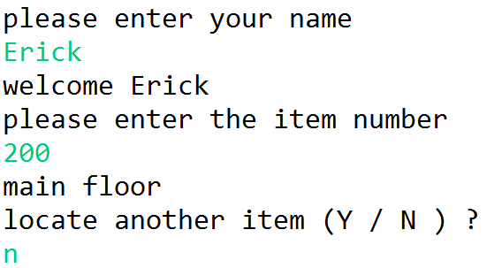**Output:**

**Modified Source Code:**

/* Programmer: Erick Cabrera, filename: Inventory.java */

import java.io.*;

// the class definition

public class Inventory

{

// declare a BufferedReader object

static BufferedReader kb = new

BufferedReader(new InputStreamReader(System.in));

public static void main(String args[]) throws IOException

{

// declare the variables that are local to main()

int itemNum = 0, intLocate = 0;

String strName = " ";

char again = 'Y';

// request and receive data from the user

System.out.println("please enter your name");

strName = kb.readLine();

System.out.println("welcome " + strName);

// enter a looping structure

while (again == 'Y')

{

System.out.println("please enter the item number");

itemNum = Integer.parseInt(kb.readLine());

// enter a group of decision statements

if (itemNum >= 1000 && itemNum <= 1999 && itemNum != 1621) intLocate = 1;

if (itemNum >= 2000 && itemNum <= 5000 && itemNum != 2175) intLocate = 2;

if (itemNum >= 5001 && itemNum <= 9000) intLocate = 3;

if (itemNum >= 9001 && itemNum <= 9999 && itemNum != 9876) intLocate = 4;

if (itemNum == 1621 || itemNum == 2175 || itemNum == 9876) intLocate = 5;

switch(intLocate)

{

case 1: System.out.println("lower level"); break;

case 2: System.out.println("main floor"); break;

case 3: System.out.println("upper level"); break;

case 4: System.out.println("mezzanine"); break;

case 5: System.out.println("item no longer available for sale"); break;

default: System.out.println("invalid number"); break;

}

intLocate =0;

System.out.println("locate another item (Y / N ) ?");

again = kb.readLine().charAt(0);

if (again == 'N') { System.exit(0); kb.close(); }

}

}

}

**Modified Output:**

